**Construct 307**

Luka Krstikj (213257)

**Introduction**

Construct 307 is a frontend web application based around the idea of allowing a potential buyer of an apartment to interactively list through apartments of buildings. The idea sprung to life while overhearing a conversation a couple of architects had around websites boosting their presence and sale of apartments. Checking out the websites they were looking at gave me an idea to improve on the concept of the topic covered in this project. First analysis of the websites that offer this feature left me with a conclusion that: Either the websites were slow due to being overly dependent on outdated technologies or plugins; The design was subpar at best; Or the implementation of the feature was of little to no quality. Given this conclusion I set out to make a prototype of the website that is being covered in this paper.

**Technologies and early stages of the project**

For the frontend framework, my personal choice is Angular. This choice stems from its prevalence in the market and the fact that its overall file structure suits me well. Angular’s robust framework and comprehensive tooling allow for efficient development and maintenance, making it ideal for building dynamic and interactive web applications.

To handle authentication and data persistence, I have utilized Firestore and Firebase Authentication. Firebase is my go-to choice because it enables me to focus more on the UI/UX and frontend aspects, which are my areas of comfort and expertise. Firebase's seamless integration with Angular facilitates a smooth development process and ensures secure and reliable data handling.

Additionally, I have employed Tailwind CSS as the CSS framework to allow easy responsive design and to set the color palette for the entire website. Tailwind CSS’s utility-first approach helps in creating a cohesive and visually appealing design with minimal effort, enabling faster development and easier maintenance of the website’s styling.

**Along the process of setting up the technologies**

Angular v17.3.0 was the most recent version at the time the work on this project was started, and the only problem concerning the version of Angular I ran into was during the setup of Firebase along the project. Given that every tutorial on the implementation of Firebase in an Angular project is obsolete in version 17 of angular. Nonetheless the first functionality to ‘get off the ground’ was the Authentication then came the Homepage and Firestore, one of the last things to be set up was the Admin Page.

**Design**

The aim for this project was to first of all establish a name, color palette and font to set the theme for the topic of the website regarding a mockup design and build company.

The name for the website was settled on ‘‘Construct [307]’’. A somewhat Neo-brutalistic approach to the name that set in motion a path for the next steps of the design.

The color palette of choice is made up of 5 primary colors. This palette resides in the tailwind config.js file.

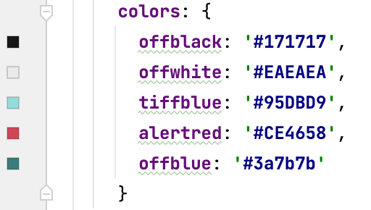









The colors of this palette have been tested for contrast and they average AA or AAA contrast levels. The main colors are the subtle off-white color that gives a warm welcome to the visitors of the website. And the most common text color on the website is charcoal black.

The greenish cyans are used as accent colors or background colors to add some variety and freshness into the website design. As well as the red color that the user sees when an apartment is Sold. While the admin sees the red on important actions such as logging out, and modifying projects, deleting or adding new projects.

After settling on the color palette of the website next came the choice for the font.

The font being used in the website is from Atipo and the font is “N27”

Atipo is an independent digital typeface foundry and graphic design studio based in Gijón (Spain) established in 2009 by Raúl García del Pomar & Ismael González.

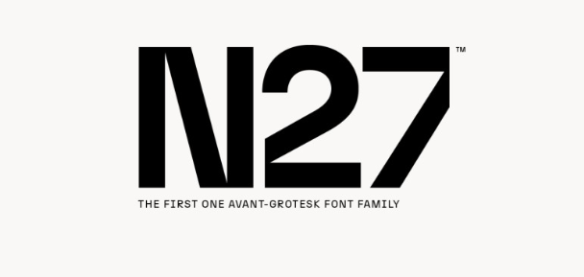

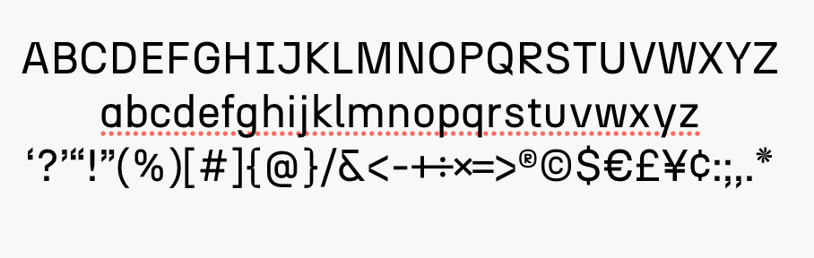

After settling on the font, the design queues going forward were set. Almost fully flat modern design, with neo-brutalistic hints.

**Page Structure**

This project has 4 user pages and 4 admin pages. The homepage of the website has mostly static content, showcasing a bold parallax effect on top of the page, scrolling down reveals a fractured image of 4 buildings each one being highlighted every five seconds and showing different selling points of the mockup “company” and below it showcasing some statistics. This is where I ran into an idea of counting up to the numbers of the statistics and in effect making it look like an animation. But I ran into a problem with the implementation when using the setInterval function. The animation was either too fast which can be fixed with adjusting the interval time, but for large numbers I didn’t find a way to make it fast enough to be reasonable for the user to wait for the counting up to finish to see the final statistic. So I made the decision to scrap this idea and leave it completely static. Scrolling further down on the page reveals a gallery of interiors paired with a big catchphrase. Below it there are three buttons that lead to the About Us page and the Projects page.

The navigation bar and the footer of every user page are simple and minimalist in nature. The navigation bar features a CSS backdrop filter to blur the background of the rest of the page being visible but subtly blended into the content of the rest of the page. While the footer is simple displaying some social media links that route to mine for the purpose of this project, as-well as displaying some contact info.

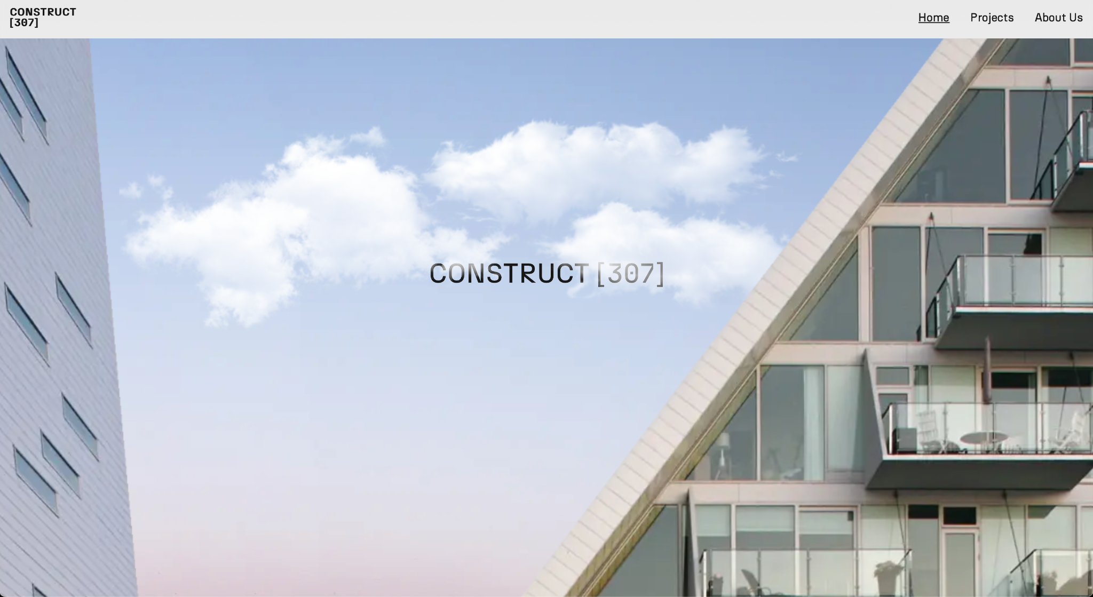

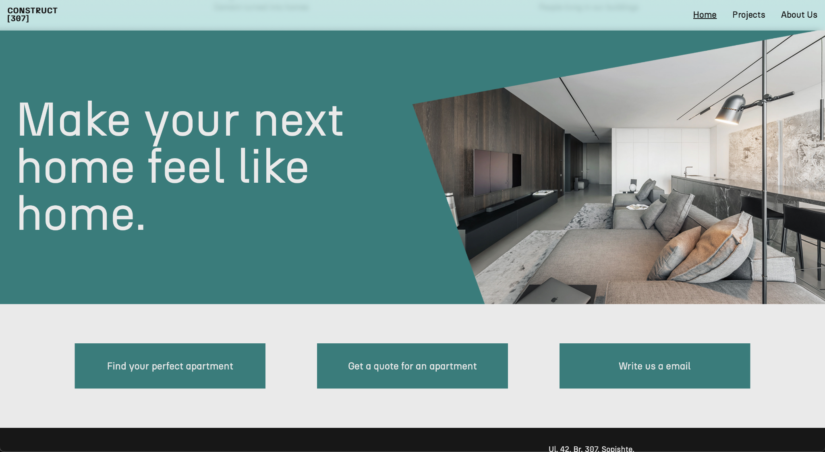

**Project and Project Detailed Pages**

The projects page since it pulls data from Firestore, it first displays a loading animation until the data is pulled. The only problem with this is since the photos are hosted outside of Firebase, and the field for the photo is a string of it’s URL there is a slight point where the data from Firebase is received but the photos aren’t and it doesn’t show the photos. This is a potential fix further down the road of the development process. After all the data is loaded, all the projects are showcased as cards with the image of the building making most of the card. When a user hovers his mouse on a card the opacity of the photo slightly decreases and the description of the building is shown also using the backdrop filter CSS property to blend and pop out of the background. The development process was smooth sailing in this area. I didn't run into any problems or challenges here, and the only changes were the styling and responsiveness of this page.

The project detail page. To me is the highlight of the whole project and where my solution of exploiting the properties of SVG elements and its path tags having irregular shapes in the DOM. Using Angulars for cycle to load the SVG. Each object of the building has its own properties about the name, description, floors, its corresponding svg path that has a click event that loads the floorplan of each floor and its apartment sizes and a boolean of them being sold or available. When a user clicks on a floor it automatically scrolls to the floorplan segment. There can be multiple addons to this page in the future and my plan is to further the development of this project to improve the user experience and overall design of the page.

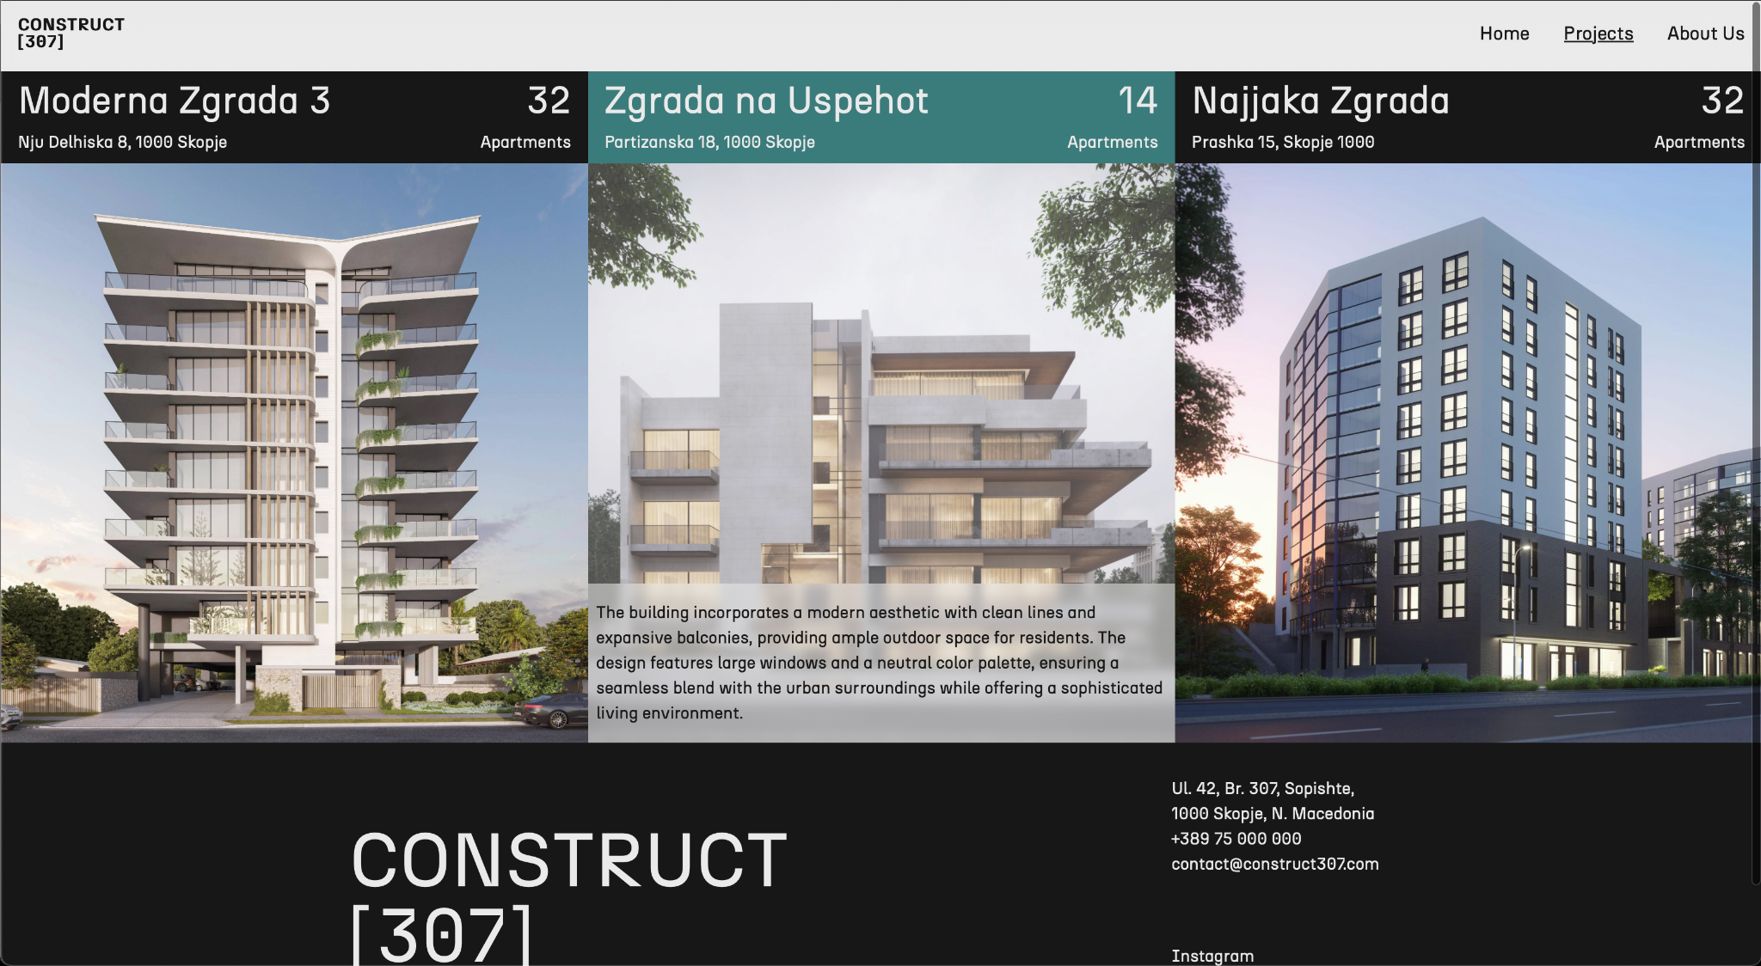

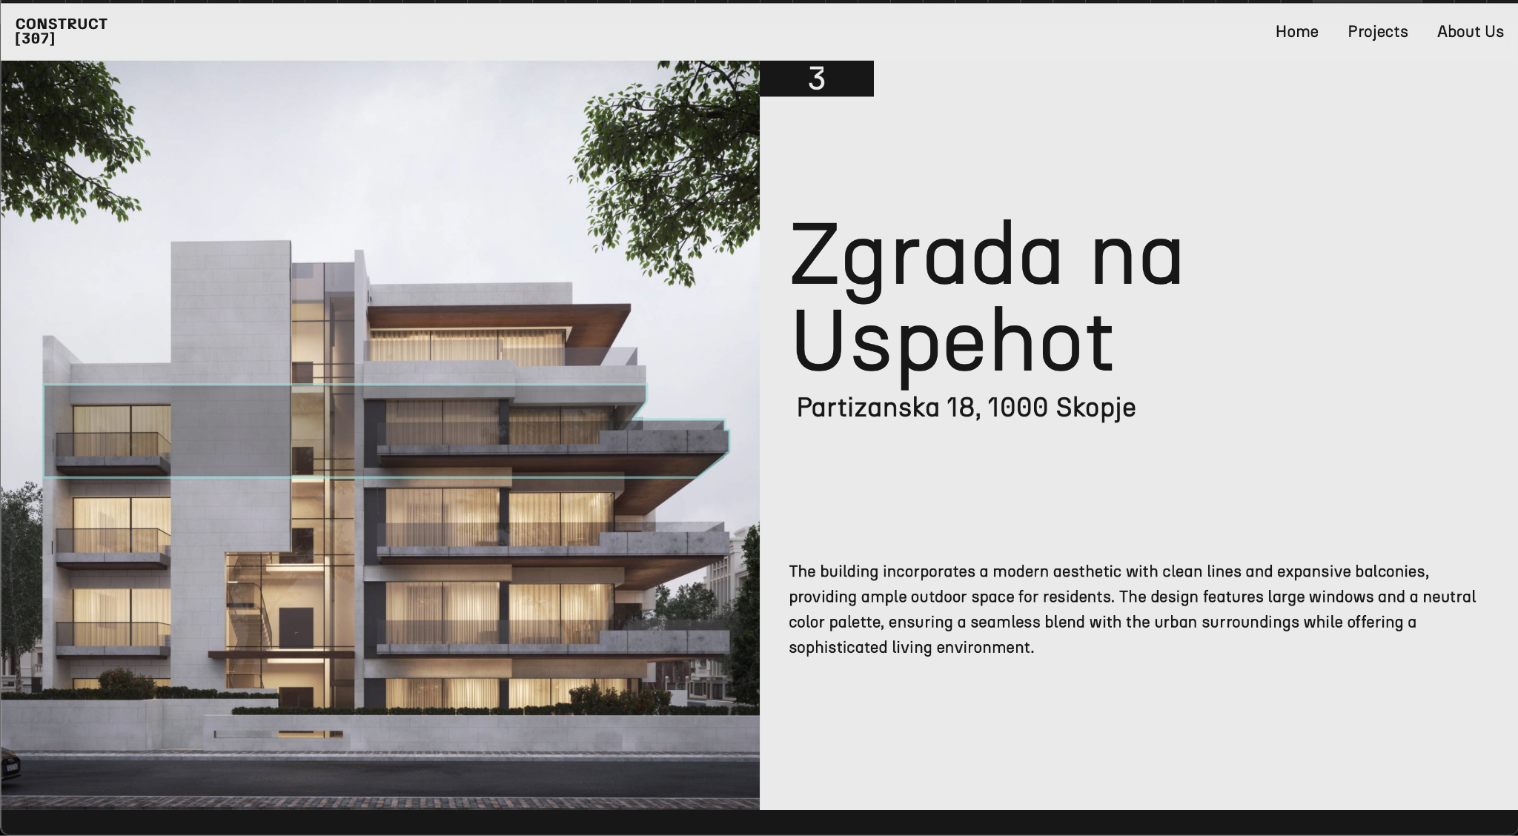

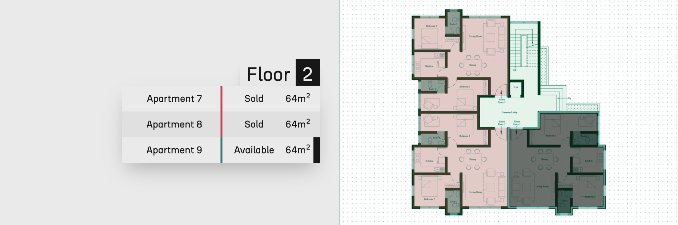

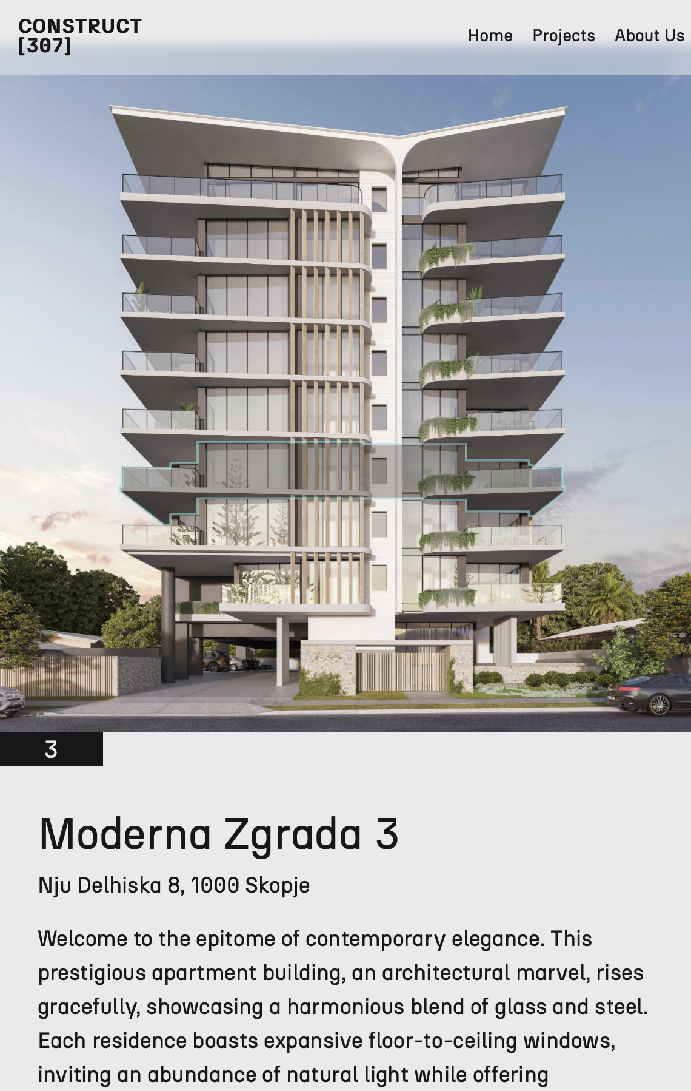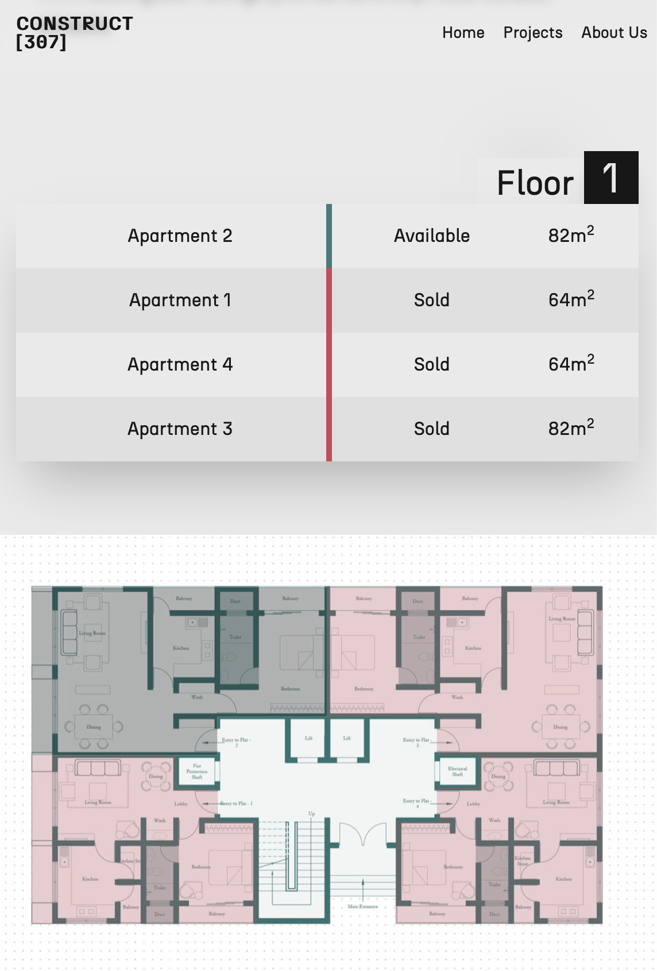f

**The admin panel**

First of all the admin page has a code on its initialization that checks if a user is logged in or not and accordingly redirects to a login page if a user is not logged in. This is done using FIrebase Authentication. The development process of this part of the page has presented little to no challenge since I have some prior experience with the Firebase Authentication in Angular. When a user is detected the admin panel can be accessed and it displays all the projects in the Firestore, allowing an admin to edit or delete objects from the database. When the admin decides to delete a project the delete button just adds a new button to confirm the action of deleting. If an admin wants to add a new project it can be done from the website and removing the need to access the Firebase dashboard. Adding a new project utilizes two way binding to display all the entered data giving a sense of how the final project will look from the user perspective, as well as minimizing the chance of the data being wrong or broken. Even in that scenario something goes wrong during adding a new project. The admin has the option to edit the project where it’s roughly the same page as the add page.

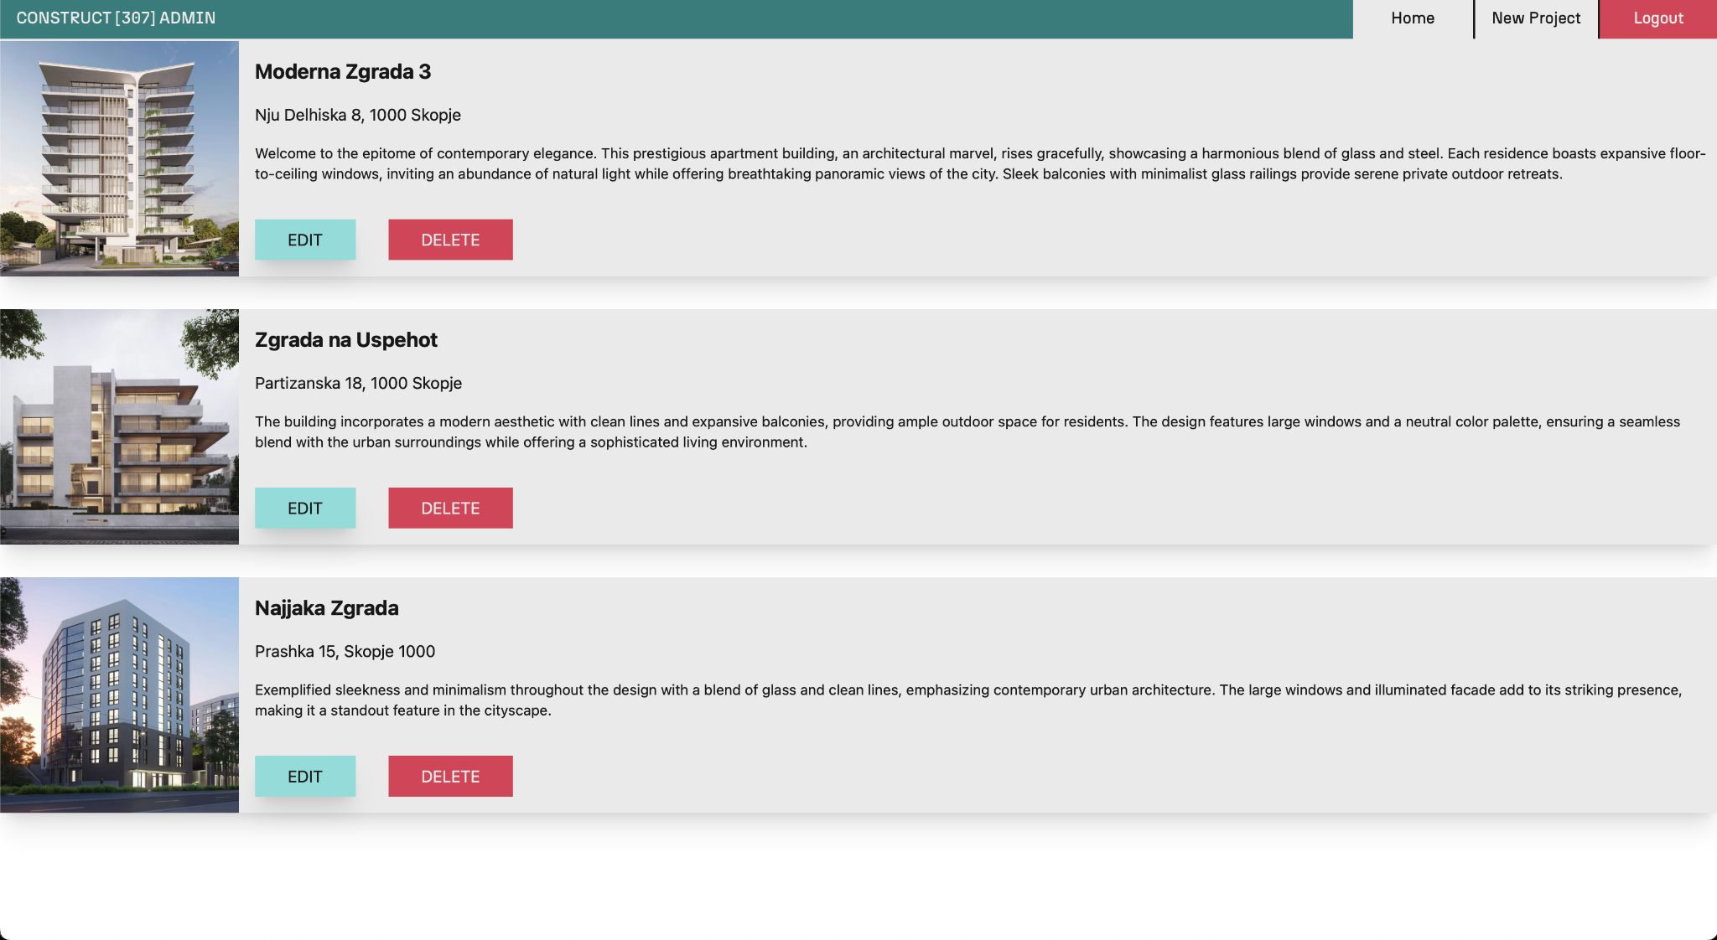

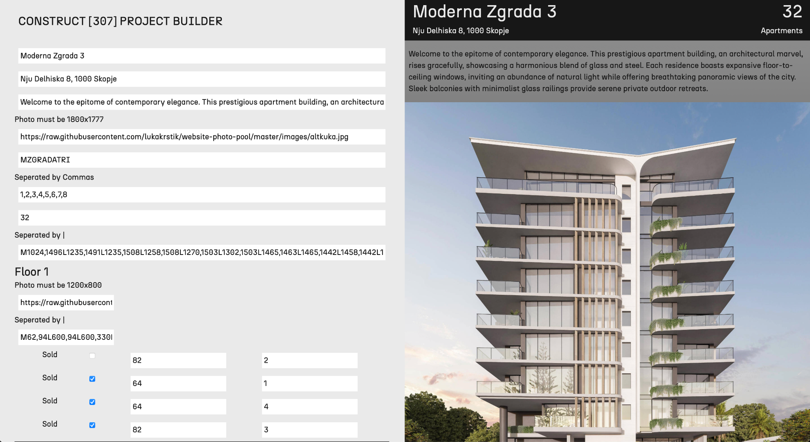

**Potential fixes and new features in the future.**

There are a lot of things I would add or change to the project in the future. Since this project offers a versatile use case that can be adapted to multiple types of buildings. I would like to add a newsletter or inquiry form on the About Us page that will offer the user to contact the company via email more conveniently. I would like to add a Gallery of the interior of each floor or possibly each apartment to further familiarize the user and increase the chance of the user investing in an apartment of the company.

The admin page could use some reworks in the sense of streamlining the extraction of the SVG paths from files instead of adding them manually. As Well as finding a solution to hosting the photos on third party sites.

Furthermore I would like to invest more in learning color theory and overall design patterns for better user experience.

The process of adding new projects still requires manual work outside of the website in the form of preparing the photos in specific resolutions and manually making the paths in programs like Adobe Illustrator. Afterwards the svg files are opened in a text editor program and the paths are extracted as strings. This can be cumbersome to a potential admin, but the specific case with buildings being a small load due to a company being limited to a couple of buildings at most yearly. Still streamlining the process is of the utmost importance in the future.

As I look towards the future development of this project, one area I am particularly excited to delve into is Angular animations. While I have successfully implemented various features and functionalities within the application, I recognize the potential that advanced animations hold for enhancing user experience and engagement. Incorporating these animations will not only improve the aesthetic appeal of Construct 307 but also enhance its usability.

**Conclusion**

Construct 307 successfully addresses the challenges of creating an interactive and efficient web application for browsing apartments. By leveraging modern technologies like Angular, Firebase, and Tailwind CSS, the project aims to set a new standard for user experience and design in the real estate market. The development process provided valuable insights into Angular, Firebase, and UI/UX design, and the application serves as a robust prototype for further enhancements and features.

This project demonstrates the potential for modern web applications to revolutionize how potential buyers interact with real estate listings. By focusing on performance, design, and usability, this project offers a compelling solution for showcasing residential buildings and enhancing the apartment-buying experience. The work on this project has been a rewarding journey, providing both practical experience and a solid foundation for future development.

As I plan to continue to develop this project, the focus will remain on improving user experience, adding new features, and refining existing functionalities. With ongoing development and user feedback, the application aims to become a leading tool in the real estate industry, setting a benchmark for interactive and engaging web design.

Also of note is that this website is hosted using Netlify and can be accessed with the following link. <https://construct.lukakrstik.com>.